# Punch through a rectangle.

File document properties Display units: px

File document properties show page border: uncheck

View custom

View zoom zoom 1:1

Align and distribute menu last selected

Edit objects colors, gradients …

Type letter A

Select the letter

Ctrl + drag to resize

Change font

Change color to grey

Path object to path

Ungroup

(test “edit path by nodes”, you should see individual nodes)

Create rectangle over the letter. Make it black. Make opacity to 50%.

Select tool click and drag over all. Center on the vertical and horizontal axis.

Hold shift and click on the rectangle to deselect that. Now only letter A is selected. Duplicate by ctrl+D.

Hold shift and select the rectangle again. Path difference.

Now we have letter A punched through the rectangle.



# Shadow effect

Click on the letter A. duplicate it. Color red. Opacity down to 40%.

Select the rectangle. The rectangle will represent the inner budged in area.

Zoom in to fill the whole screen with A.

Disable snapping by pressing ctrl+%. Move the rectangle slightly towards south east. The red and black intersecting area is going to be the shadow area. i.e. the dark red portion in the following picture.



Hold shift and click letter A. so both are selected now. Object clip set.

Opacity back to 100%. Blur raise little bit e.g. 1%. Opacity back to 50%.

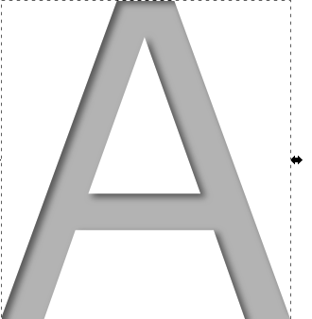

# Shadow from all directions

Click on the shadow object. You can make sure by looking at the selected color in the south west palette.

Object clip release. Click outside to deselect everything.

Select the rectangle. Blur to 0.

Hold shift and select A. center on vertical and horizontal.

Hold shift and deselect A. hold shift and click on color black.

Shit click A. object clip set. Increase blur to 1%.

